Mastering GDAL Tools (Course Material)

Satellite and aerial image processing using GDAL tools

Ujaval Gandhi

Table of Contents

**This course is also offered as an in-person class. If you would like to attend one of my workshops, visit** [**www.spatialthoughts.com/events**](https://spatialthoughts.com/events/) **to know details of upcoming classes. You may also sign up for** [**my mailing list**](https://mailchi.mp/1d44f6c0c955/spatialthoughts) **to know when new sessions are scheduled.**

# Introduction

[GDAL](https://gdal.org/) is an open-source library for raster and vector geospatial data formats. The library comes with a vast collection of utility programs that can perform many geoprocessing tasks. This class introduces GDAL utilities with example workflows for processing satellite and aerial imagery.

# Get the Data Package

The code examples in this class use a variety of datasets. All the required datasets are available in the [gdal_tools.zip](http://bit.ly/gdal-tools-data) [~1.3GB]. Download and unzip this file to the Downloads directory. All commands below assume the data is available in the <home folder>/Downloads/gdal_tools/ directory.

# Running GDAL Commands

On Windows, the easiest way to run the gdal commands is via the **OSGeo4W Shell**. To install GDAL commands, download the [OsGeo4W Installer](https://trac.osgeo.org/osgeo4w/) and run Express Install. Once installed, launch the *OsGeo4W Shell* and cd to the gdal_tools directory.

**Note:** Many commandline examples are long and span multiple lines. To improve readability, they are separated by **^** character at the end if each line. This is a line continuation character that enables the OsGeo4W shell to interpret it as a single command. If you are running these on Mac or Linux, replace the **^** character with **\**

# Processing Satellite Data

This section shows how to take satellite data from Landsat-8 and create various derived products.

## Merging individual bands into RGB composite

gdal_merge -o rgb.tif -separate ^  
 -co PHOTOMETRIC=RGB -co COMPRESS=DEFLATE ^  
 landsat8/RT_LC08_L1TP_137042_20190920_20190926_01_T1_2019-09-20_B4.TIF ^  
 landsat8/RT_LC08_L1TP_137042_20190920_20190926_01_T1_2019-09-20_B3.TIF ^  
 landsat8/RT_LC08_L1TP_137042_20190920_20190926_01_T1_2019-09-20_B2.TIF

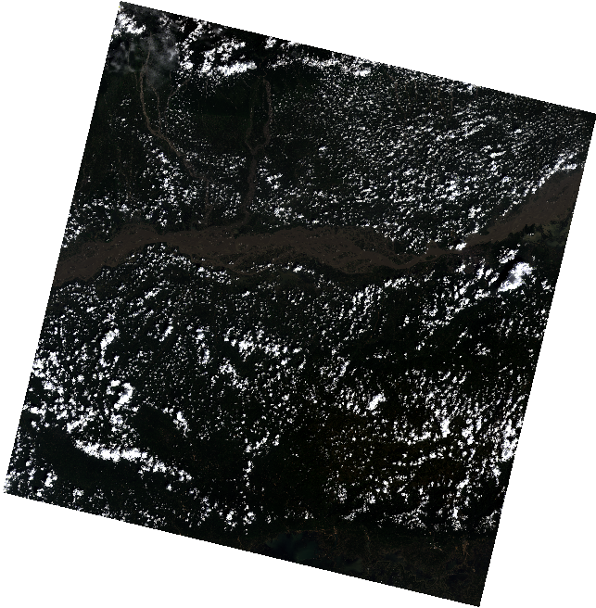

## Apply Histogram Stretch and Color Correction

gdal_translate -scale 0 0.3 0 255 -exponent 0.5 -ot Byte ^  
 rgb.tif rgb_stretch.tif

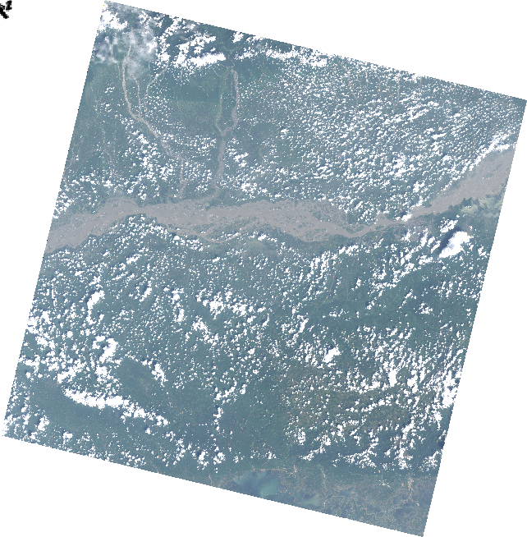

## Pan Sharpening

gdal_pansharpen ^  
 landsat8/RT_LC08_L1TP_137042_20190920_20190926_01_T1_2019-09-20_B8.TIF ^  
 rgb.tif pansharpened.tif -r bilinear -co COMPRESS=DEFLATE -co PHOTOMETRIC=RGB  
  
gdal_translate -scale 0 0.3 0 255 -exponent 0.5 -ot Byte -a_nodata 0 ^  
 pansharpened.tif pansharpened_stretch.tif

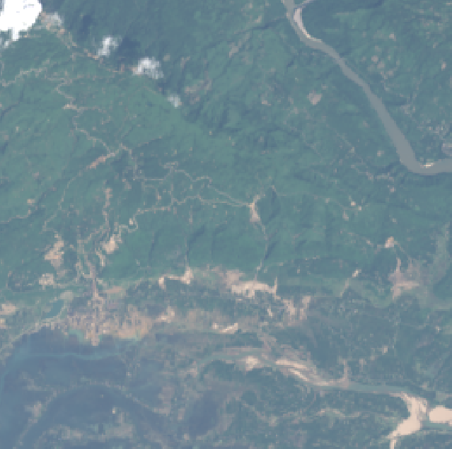

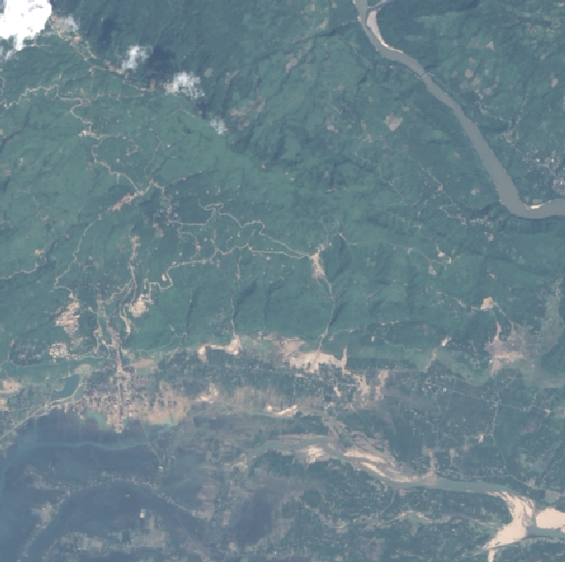

## Computing NDVI

gdalinfo -stats ^  
 landsat8/RT_LC08_L1TP_137042_20190920_20190926_01_T1_2019-09-20_B4.TIF

It is important to set nodata value. As seen from the output above, nodata is set to -999.

gdal_calc ^  
 -A landsat8/RT_LC08_L1TP_137042_20190920_20190926_01_T1_2019-09-20_B5.TIF ^  
 -B landsat8/RT_LC08_L1TP_137042_20190920_20190926_01_T1_2019-09-20_B4.TIF ^  
 --outfile ndvi.tif --calc="(A-B)/(A+B)" --NoDataValue=-999

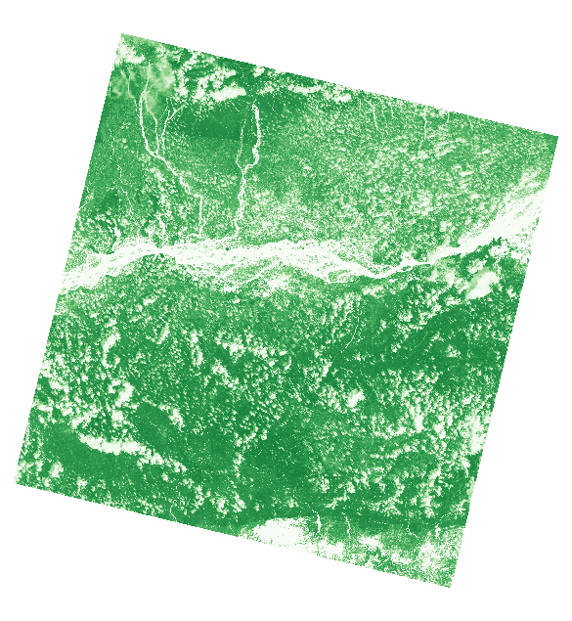

# Georeferencing

## Georeferencing images with corner coordinates

You can easily assign bounding box coordinates to any image using the a_ullr option.

gdalinfo earth_at_night.jpg  
  
gdal_translate -a_ullr -180 90 180 -90 -a_srs EPSG:4326 ^  
 earth_at_night.jpg earth_at_night.tif ^  
 -co PHOTOMETRIC=RGB -co COMPRESS=DEFLATE  
  
gdalinfo earth_at_night.tif

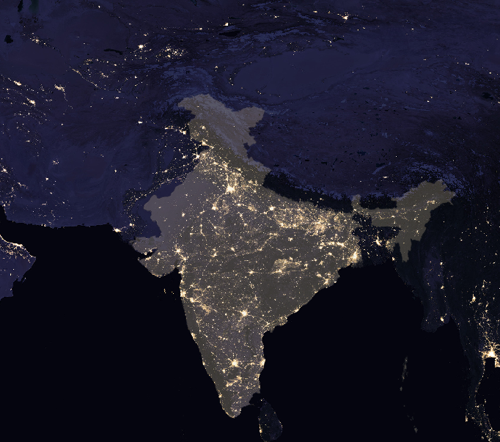

## Georeferencing with GCPs

GCP format is [pixel line X Y]. You can use QGIS Georeferencer to obtain the GCPs. Ideally, this process is used with images that have known corner coordinates. In that case, if you know the image dimensions, pixel and line values can be obtained easily.

Let’s georeference this old scanned map.

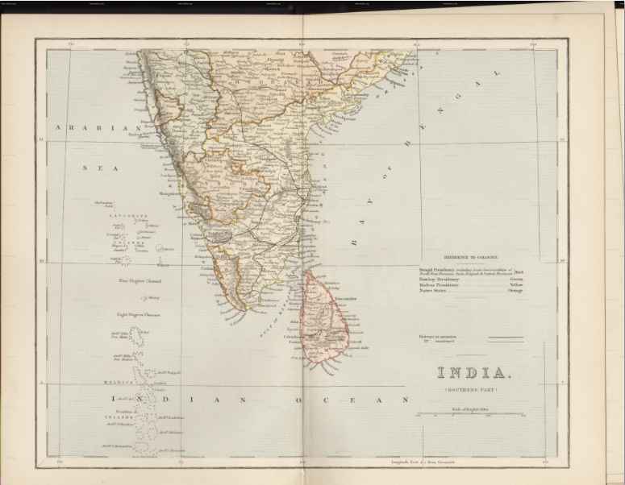

First store the GCPs in the file

gdal_translate ^  
 -gcp 418 893 70 15 ^  
 -gcp 380 2432 70 5 ^  
 -gcp 3453 2434 90 5 ^  
 -gcp 3407 895 90 15 ^  
 -gcp 2662 911 85 15 ^  
 1870_southern-india.jpg india-with-gcp.tif

Next, reproject the image using the GCPs

gdalwarp -t_srs EPSG:4042 -r bilinear -tr 0.005 0.005 -overwrite ^  
 india-with-gcp.tif india-reprojected.tif

Try a Thin-plate-spline transformation with some compression options.

gdalwarp -t_srs EPSG:4042 -tps -r bilinear -tr 0.005 0.005 -overwrite ^  
 india-with-gcp.tif india-reprojected.tif ^  
 -co COMPRESS=JPEG -co JPEG_QUALITY=50 -co PHOTOMETRIC=YCBCR

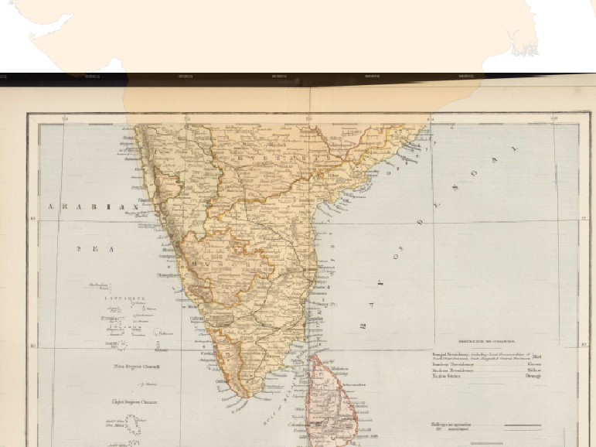

# Processing of Aerial Imagery

## Create a preview image from source tiles

gdalbuildvrt naip.vrt naip/*.jp2  
gdal_translate -of JPEG -outsize 2% 2% naip.vrt naip_preview.jpg

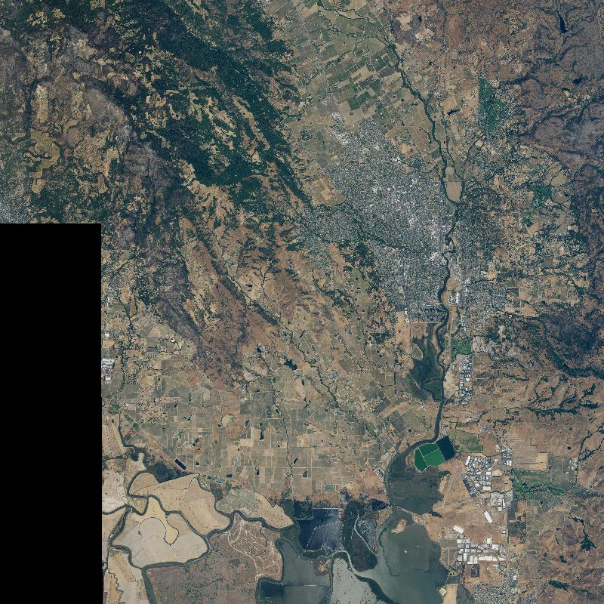

## Select a subset of tiles

gdaltindex index.shp naip/*.jp2

We have the area of interest defined in the aoi.shp file. We want to select and mosaic only the tiles intersecting our AOI

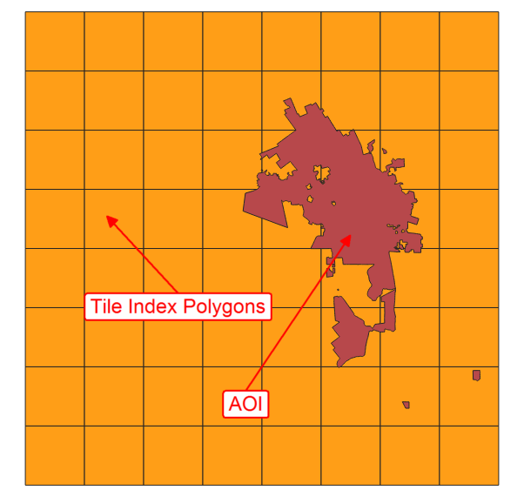

Select and save the intersecting tiles using *Extract by Location* Processing algorithm in QGIS and save the selection as a CSV file selection.csv.

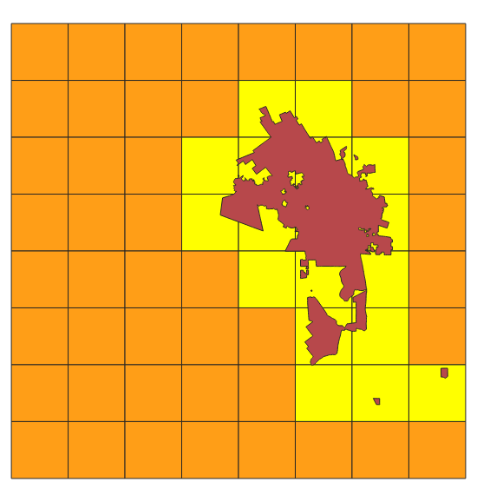

Edit the file to remove the header line. This creates a text file with source tile locations that can be supplied to the gdalbuildvrt command.

gdalbuildvrt -input_file_list selected.csv aoi.vrt

## Mosaic and clip to AOI

gdalwarp -cutline naip/aoi.shp -crop_to_cutline aoi.vrt aoi.tif ^  
 -co PHOTOMETRIC=RGB -co COMPRESS=DEFLATE -dstnodata 0

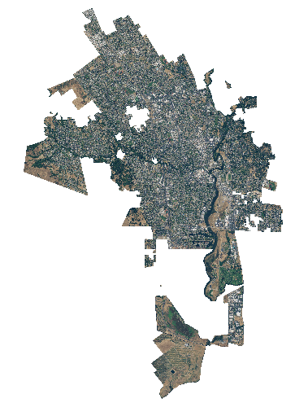

# Multi Criteria Weighted Overlay Analysis

Multi-criteria analysis is the process of the allocation of land to suit a specific objective on the basis of a variety of attributes that the selected areas should possess.

Although this is a common GIS operation, it is best performed in the raster space. Below is the typical workflow to take source vector data, transform them to appropriate rasters, re-classify them and perform mathematical operations to do a suitability analysis.

The problem statement is **Locate the suitable areas for development**, that are

* Close to roads
* Away from waterbodies
* Not in protected areas

## Rasterize vector layers

For overlay analysis, all rasters must be of the same extent. So we first find the extent of the dataset that we can use while rasterizing.

ogrinfo -so osm/assam.gpkg boundary

gdal_rasterize -ot Int16 -burn 1 -tr 15 15 -te 170134 2669018 798842 3097324 ^  
 osm/assam.gpkg -l roads roads.tif

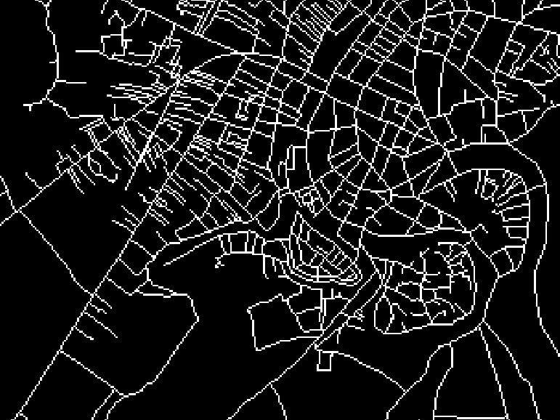

gdal_rasterize -ot Int16 -burn 1 -tr 15 15 -te 170134 2669018 798842 3097324 ^  
 osm/assam.gpkg -l boundary boundary.tif

Use -i for inverse rasterization. We want to rasterize ‘un-protected’ areas

gdal_rasterize -i -ot Int16 -burn 1 -tr 15 15 -te 170134 2669018 798842 3097324 ^  
 osm/assam.gpkg -l protected_regions protected_regions.tif

We need a water layer, but the source data has a polygon and a polyline water features layer. We create 2 rasters and then add them to create a single water features raster.

gdal_rasterize -ot Int16 -burn 1 -tr 15 15 -te 170134 2669018 798842 3097324 ^  
 osm/assam.gpkg -l water_polygons water_polygons.tif  
  
gdal_rasterize -ot Int16 -burn 1 -tr 15 15 -te 170134 2669018 798842 3097324 ^  
 osm/assam.gpkg -l water_polylines water_polylines.tif  
  
  
gdal_calc -A water_polygons.tif -B water_polylines.tif ^  
 --outfile water_add.tif --calc="A+B"  
  
gdal_calc -A water_add.tif --outfile water.tif ^  
 --calc="A>0"

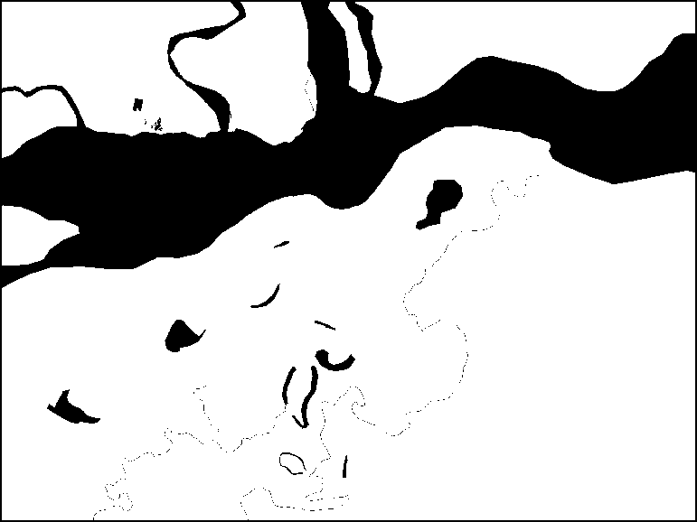

## Generate proximity (Euclidean distance) rasters

gdal_proximity roads.tif roads_proximity.tif ^  
 -ot Int16 -distunits GEO  
  
gdal_proximity water.tif water_proximity.tif ^  
 -ot Int16 -distunits GEO

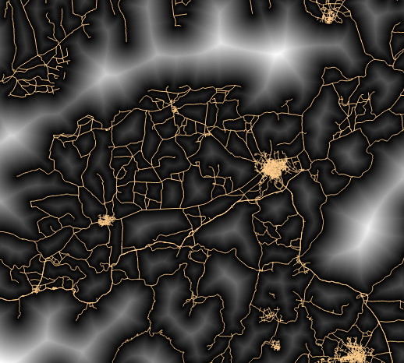

## Re-classify raster values

**Roads** Give higher score to nearer pixels

0-1000m –> 100

1000-5000m –> 50

>5000m –> 10

gdal_calc -A roads_proximity.tif --outfile roads_class.tif ^  
 --calc="100*(A<=1000) + 50*(A>1000)*(A<=5000) + 10*(A>5000)"

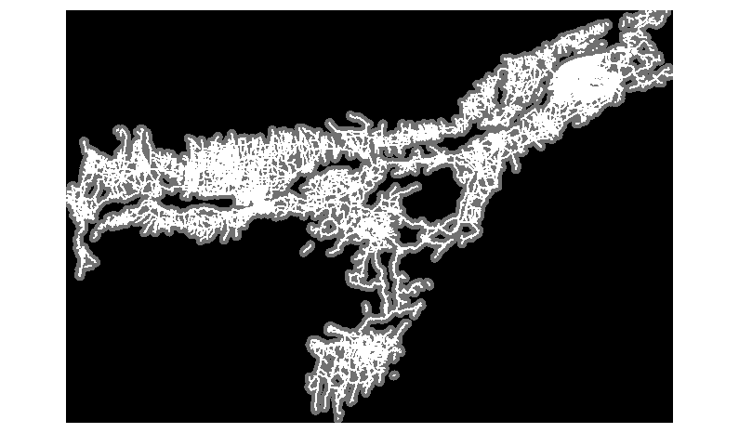

**Water** Give lower score to nearer pixels

0-1000m –> 10

1000 -5000m —> 50

>5000m –> 100

gdal_calc -A water_proximity.tif --outfile water_class.tif ^  
 --calc="100*(A>5000) + 50*(A>1000)*(A<=5000) + 10*(A<1000)"

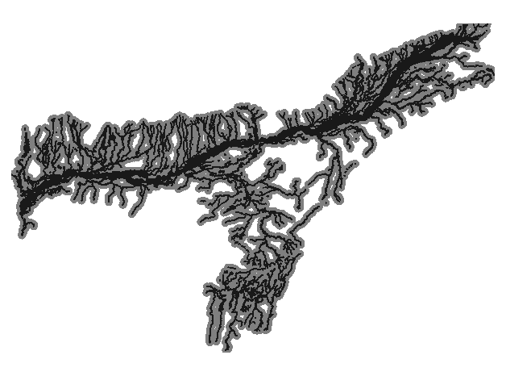

## Overlay analysis

Roads and Water have a range of values, but protected areas are either 0 or 1. So we combine these together accordingly.

gdal_calc ^  
 -A roads_class.tif -B water_class.tif -C protected_regions.tif -D boundary.tif ^  
 --outfile suitability.tif --calc="(A + B)*(C>0)*D" --NoDataValue=0

Smooth the output

gdalwarp -r cubicspline -tr 60 60 -dstnodata 0 ^  
 suitability.tif suitability_final.tif

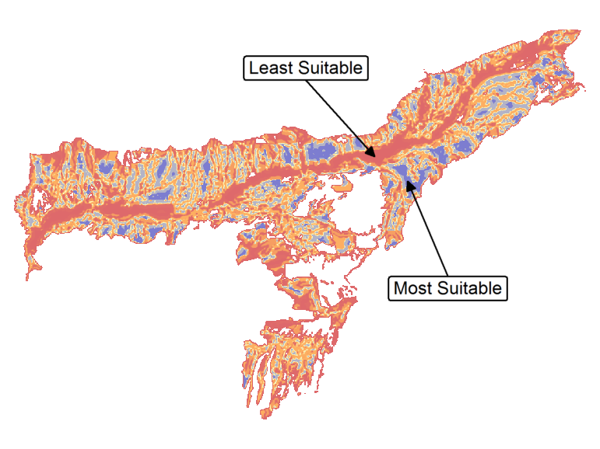

# Running commands in batch

You can run the GDAL/OGR commands in a loop using Python. Open OSGeo4W Shell and type the following to set the correct system paths

py3_env

Say you want to convert the format of the images from JPEG200 to GeoTiff. You would run a command such as below.

gdal_translate -of GTiff -co COMPRESS=JPEG {input} {output}

But it would be a lot of manual effort if you want to run the commands on hundreds of input files. Here’s where a simple python script can help you automate running the commands in a batch. The data directory contains a file called batch.py with the following python code.

import os  
  
input_dir = 'naip'  
  
command = 'gdal_translate -of GTiff -co COMPRESS=JPEG {input} {output}'  
for file in os.listdir(input_dir):  
 if file.endswith('.jp2'):  
 input = os.path.join(input_dir, file)  
 filename = os.path.splitext(os.path.basename(file))[0]  
 output = os.path.join(input_dir, filename + '.tif')  
 os.system(command.format(input=input, output=output))

In OsGeo4W shell, run the following command to start batch processing on all tiles contained in the naip/ directory.

python3 batch.py

The data directory also contains an example of running the batch commands in parallel using python’s built-in multiprocessing library. If your system has multi-core CPU, running commands in parallel like this on multiple threads can give you performance boost over running them in series.

import os  
from multiprocessing import Pool  
from timeit import default_timer as timer  
  
input_dir = 'naip'  
  
command = 'gdal_translate -of GTiff -co COMPRESS=JPEG {input} {output}'  
  
def process(file):  
 input = os.path.join(input_dir, file)  
 filename = os.path.splitext(os.path.basename(file))[0]  
 output = os.path.join(input_dir, filename + '.tif')  
 os.system(command.format(input=input, output=output))  
   
files = [file for file in os.listdir(input_dir) if file.endswith('.jp2')]  
  
if __name__ == '__main__':  
 start = timer()  
 p = Pool(4)  
 p.map(process, files)  
 end = timer()  
 print(end - start)  
   
 start = timer()  
 for file in files:  
 process(file)  
 end = timer()  
 print(end - start)

The script runs the commands both in parallel and serial mode and prints the time taken by each of them.

python3 batch-parallel.py

# Data Credits

* OpenStreetMap (osm) data layers: Data/Maps Copyright 2019 Geofabrik GmbH and OpenStreetMap Contributors. [OSM India free extract](https://download.geofabrik.de/asia/india.html) downloaded from Geofabrik.
* Landsat: Landsat-8 image courtesy of the U.S. Geological Survey. Image downloaded from [Google Cloud Platform](https://console.cloud.google.com/marketplace/details/usgs-public-data/landast) and pre-processed using [Semi Automatic Classification Plugin from QGIS](https://fromgistors.blogspot.com/p/semi-automatic-classification-plugin.html)
* Earth at Night image: Credit: NASA Earth Observatory/NOAA NGDC. Earth at Night flat hi-resolution map downloaded from [NASA earth observatory](https://earthobservatory.nasa.gov/features/NightLights/page3.php)
* William Mackenzie 1870 map of Southern India: out-of-copyright scanned map downloaded from [Hipkiss’s Scanned Old Maps](http://www.hipkiss.org/data/maps.html)
* NAIP 2016 Aerial Imagery for California: The National Agriculture Imagery Program (NAIP). USDA-FSA-APFO Aerial Photography Field Office. Downloaded from [NRCS](https://nrcs.app.box.com/v/naip/folder/18144379349)

# License

This course is licensed under a [Creative Commons Attribution 4.0 International License](http://creativecommons.org/licenses/by/4.0/deed.en_US). You are free to use the material in any form as you wish. Kindly give appropriate credit to the original author.

© 2019 Ujaval Gandhi [www.spatialthoughts.com](http://spatialthoughts.com)